Linux project -David hurley R00150748

Q1. users

Adding 5 users, Alice, Bob, john, Charlie and Alex.

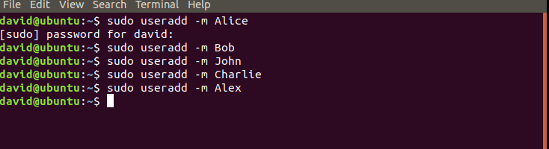

Set all there paswords to “password”

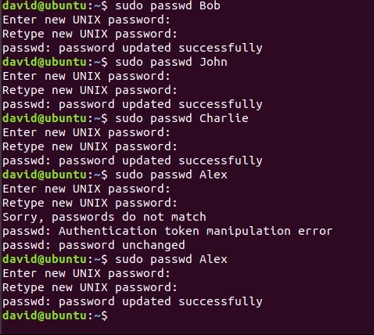

Setting up the groups



Adding the users to the groups.

I will be adding alice, bob and Charlie to groupA and Charlie alex and john to groupB

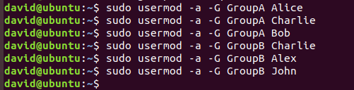

Making sure there all there

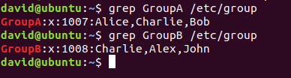

Q2. Partitioning

Creating First partition

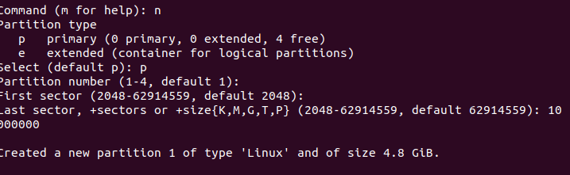

Second partition

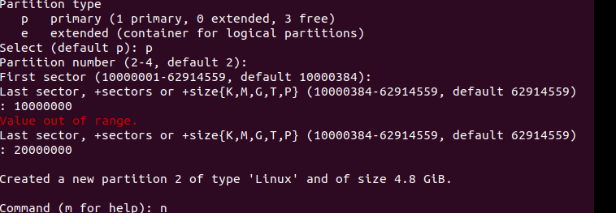

Third partition

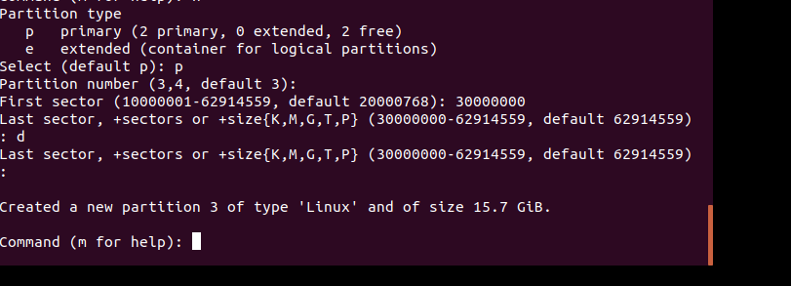

Making file system: repeated for sdb1, sdb2 and sdb3

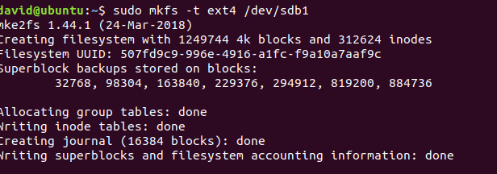

Editing my fstab file:

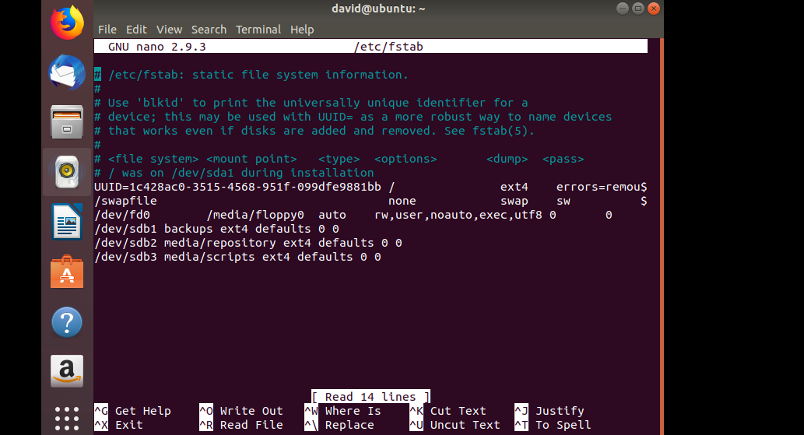

Making new directorys:

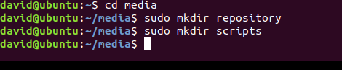

Mount all my drive:

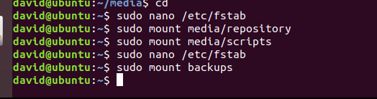

Q3.

Make directories:



Setting up our cron to run at 5 am to back up logs



This is the script we use to backup for the second part of 3.

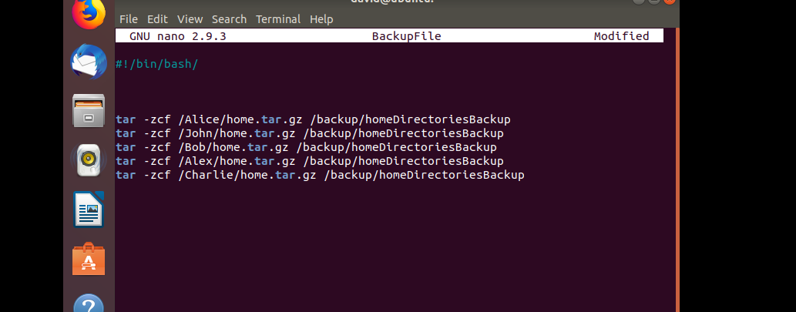

And this is how we cron it

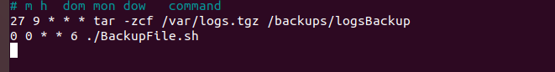

Q4.

Change the directory to read only :

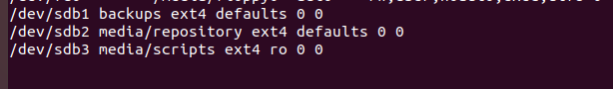

Making the files in the scripts part:

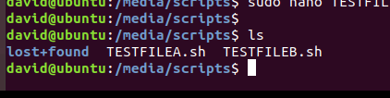

Changing GroupA to the owner of repository:



Change the permissions of the group for the repository to write only:



Giving the groups file ownership:

x

changing the file permissions to be executable by the users:

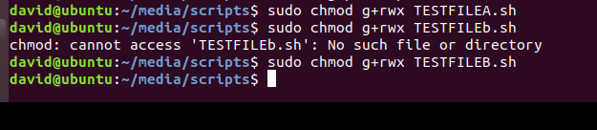

Q5.

This is how we will set up our monitoring.

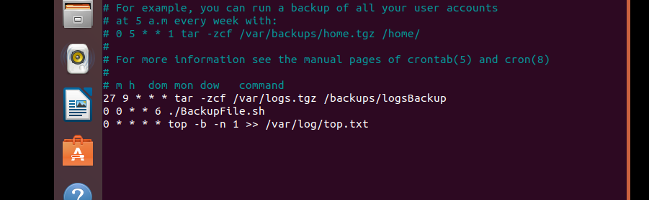

Q6.

We can see ssh is already installed and is running.

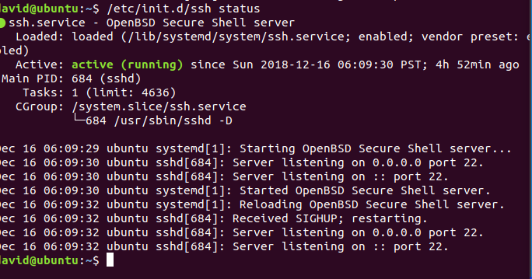

Q7.

Getting the nfs installed on the host

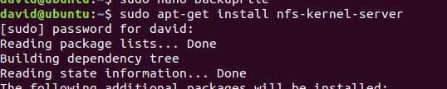

Getting the nfs installed on the client

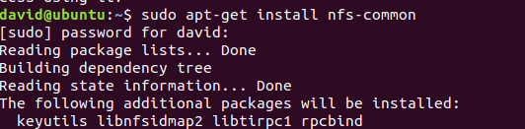

Host ip address:

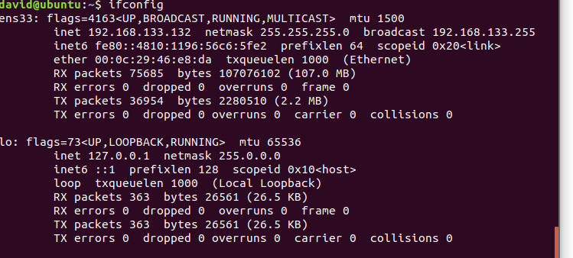

Client ip address:

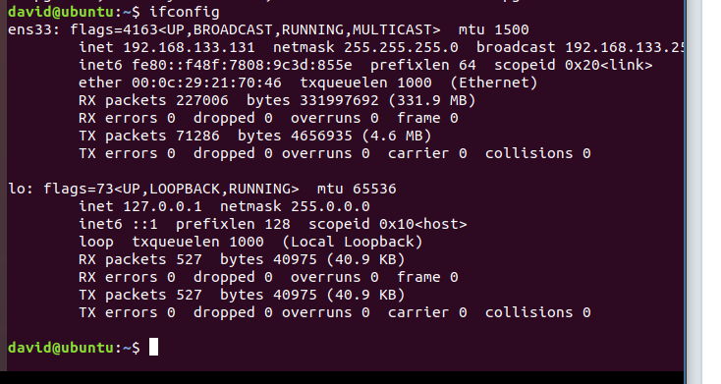

Making the directories on the host:

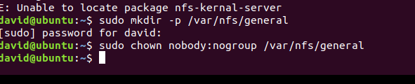

Configure nfs exports on the host:

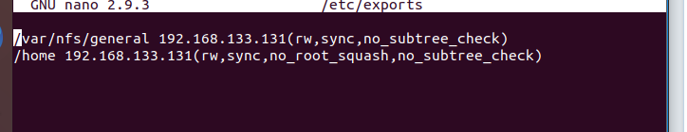

Reset server:



Adding the exceptions after enabling firewall:

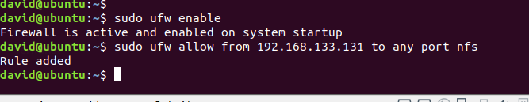

Making mount points on client:



No errors when attempting to mount them.

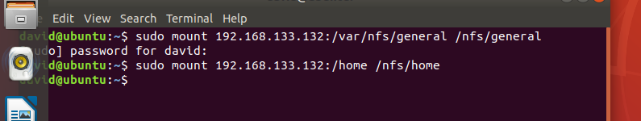

Q8.

Installing:

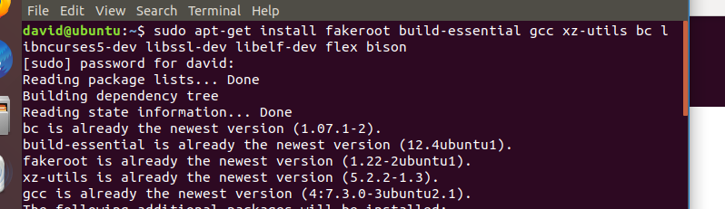

Downloading kernel source code:

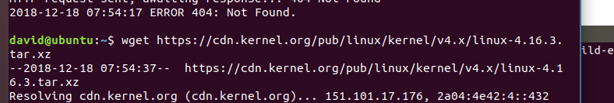

Extracting the tar file:



Getting my existing kernel to use as a basis: 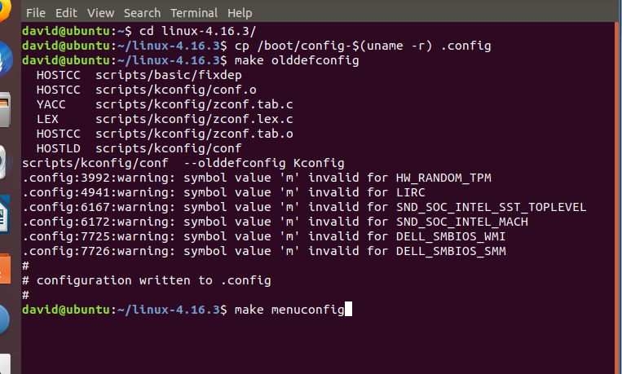

Customising our kernal:

Turing off ipv6 support

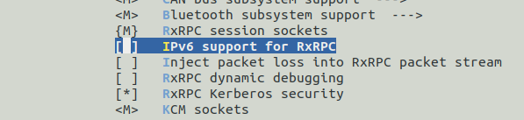

Turning off radio support:

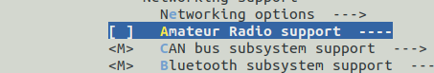

Turn off all kernal hacking :

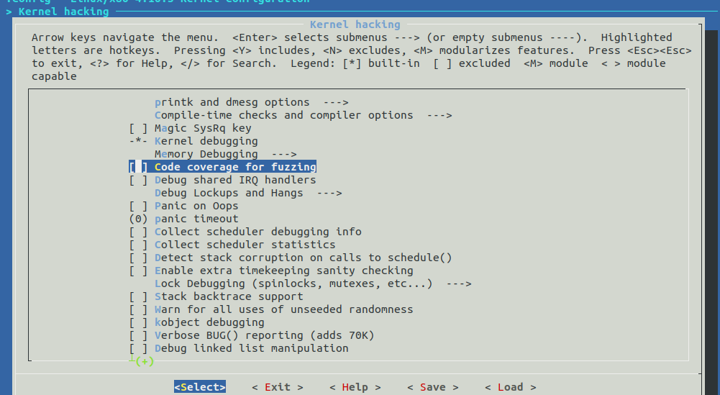

Remove support for amd and centaur processors:

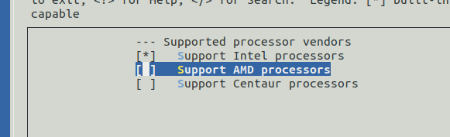

Disable hyperthreading support:



Removed guest support:

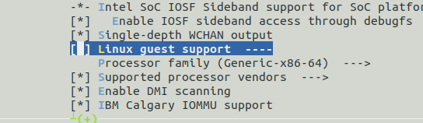

Include opatunistic sleep:

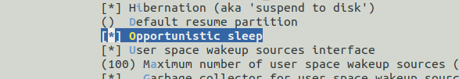

Ran make clean:



I ran into problems running the compiling command given to us in the documentation:

